**INDIA GENERAL ELECTIONS 2024 RESULT ANALYSIS**

Steps-

Step 1: loaded 5 tables- partywise_results, constituencywise_results, constituencywise_details, statewise_results, states into excel.

Step 2: checked datatype of each column and cleaned the data.

Step 3: created a database in MySQL.

Step 4: loaded all five tables into the database.

Step 5: created a sample schema of the tables and joins.

Step 6: question analysis in SQL.

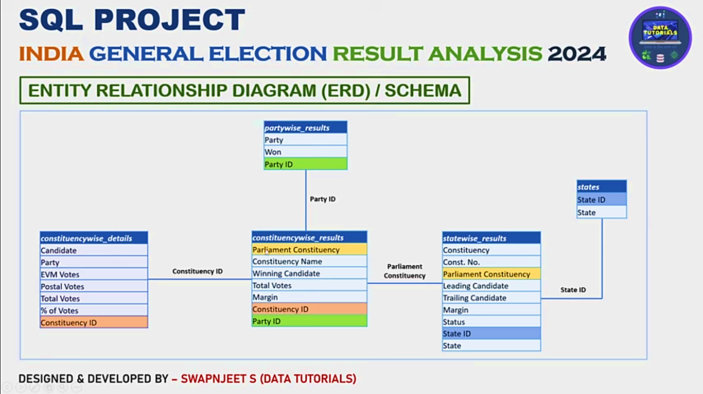

**Problem statement-**

1. Total seats.
2. What are total numbers of seats available for elections in each state.
3. Total seats won by nda alliances
4. Seats won by NDA alliance parties
5. Total seats wo by I.N.D.I.A Alliance
6. Seats won by I.N.D.I.A Alliance Parties
7. ADD new column field in table partywise results to get the party Allianz as NDA, I.N.D.I.A and other
8. Which party alliance (NDA, I.N.D.A or OTHER) won the most seats across all states?

**Functions we are going to learn in this chapter-**

Distinct

Counts()

Sum()

Case()

Join()

On

Order by()

Group by()

Max()

Row number()

Select()

Partition by

Over()

With

Update

Alter table

Add

Set

Where

Then

Else

Having

Window()

Cte

Avg()

Rank

Date functions

Inner join

Left join

Multi join

Multi table joins

Schemas

If()

Caste()

**Questions**

**Total Seats**

SELECT

DISTINCT COUNT (Parliament_Constituency) AS Total_Seats

FROM constituencywise_results



**What is the total number of seats available for elections in each state**

SELECT

s.State AS State_Name,

COUNT(cr.Constituency_ID) AS Total_Seats_Available

FROM

constituencywise_results cr

JOIN

statewise_results sr ON cr.Parliament_Constituency = sr.Parliament_Constituency

JOIN

states s ON sr.State_ID = s.State_ID

GROUP BY

s.State

ORDER BY

s.State;

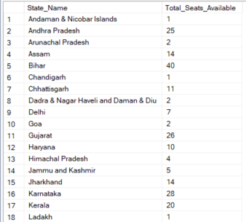 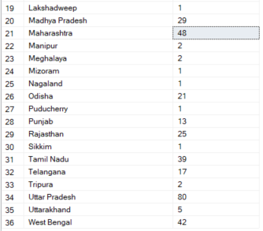

**Total Seats Won by NDA Allianz**

SELECT

SUM(CASE

WHEN party IN (

'Bharatiya Janata Party - BJP',

'Telugu Desam - TDP',

'Janata Dal (United) - JD(U)',

'Shiv Sena - SHS',

'AJSU Party - AJSUP',

'Apna Dal (Soneylal) - ADAL',

'Asom Gana Parishad - AGP',

'Hindustani Awam Morcha (Secular) - HAMS',

'Janasena Party - JnP',

'Janata Dal (Secular) - JD(S)',

'Lok Janshakti Party(Ram Vilas) - LJPRV',

'Nationalist Congress Party - NCP',

'Rashtriya Lok Dal - RLD',

'Sikkim Krantikari Morcha - SKM'

) THEN [Won]

ELSE 0

END) AS NDA_Total_Seats_Won

FROM

partywise_results

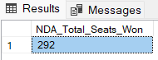

**Seats Won by NDA Allianz Parties**

SELECT

party as Party_Name,

won as Seats_Won

FROM

partywise_results

WHERE

party IN (

'Bharatiya Janata Party - BJP',

'Telugu Desam - TDP',

'Janata Dal (United) - JD(U)',

'Shiv Sena - SHS',

'AJSU Party - AJSUP',

'Apna Dal (Soneylal) - ADAL',

'Asom Gana Parishad - AGP',

'Hindustani Awam Morcha (Secular) - HAMS',

'Janasena Party - JnP',

'Janata Dal (Secular) - JD(S)',

'Lok Janshakti Party(Ram Vilas) - LJPRV',

'Nationalist Congress Party - NCP',

'Rashtriya Lok Dal - RLD',

'Sikkim Krantikari Morcha - SKM'

)

ORDER BY Seats_Won DESC

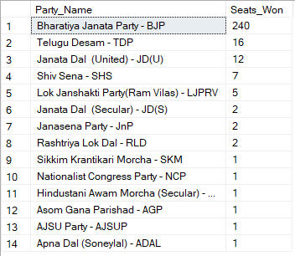

**Total Seats Won by I.N.D.I.A. Allianz**

SELECT

SUM(CASE

WHEN party IN (

'Indian National Congress - INC',

'Aam Aadmi Party - AAAP',

'All India Trinamool Congress - AITC',

'Bharat Adivasi Party - BHRTADVSIP',

'Communist Party of India (Marxist) - CPI(M)',

'Communist Party of India (Marxist-Leninist) (Liberation) - CPI(ML)(L)',

'Communist Party of India - CPI',

'Dravida Munnetra Kazhagam - DMK',

'Indian Union Muslim League - IUML',

'Nat`Jammu & Kashmir National Conference - JKN',

'Jharkhand Mukti Morcha - JMM',

'Jammu & Kashmir National Conference - JKN',

'Kerala Congress - KEC',

'Marumalarchi Dravida Munnetra Kazhagam - MDMK',

'Nationalist Congress Party Sharadchandra Pawar - NCPSP',

'Rashtriya Janata Dal - RJD',

'Rashtriya Loktantrik Party - RLTP',

'Revolutionary Socialist Party - RSP',

'Samajwadi Party - SP',

'Shiv Sena (Uddhav Balasaheb Thackrey) - SHSUBT',

'Viduthalai Chiruthaigal Katchi - VCK'

) THEN [Won]

ELSE 0

END) AS INDIA_Total_Seats_Won

FROM

partywise_results

**Seats Won by I.N.D.I.A. Allianz Parties**

SELECT

party as Party_Name,

won as Seats_Won

FROM

partywise_results

WHERE

party IN (

'Indian National Congress - INC',

'Aam Aadmi Party - AAAP',

'All India Trinamool Congress - AITC',

'Bharat Adivasi Party - BHRTADVSIP',

'Communist Party of India (Marxist) - CPI(M)',

'Communist Party of India (Marxist-Leninist) (Liberation) - CPI(ML)(L)',

'Communist Party of India - CPI',

'Dravida Munnetra Kazhagam - DMK',

'Indian Union Muslim League - IUML',

'Nat`Jammu & Kashmir National Conference - JKN',

'Jharkhand Mukti Morcha - JMM',

'Jammu & Kashmir National Conference - JKN',

'Kerala Congress - KEC',

'Marumalarchi Dravida Munnetra Kazhagam - MDMK',

'Nationalist Congress Party Sharadchandra Pawar - NCPSP',

'Rashtriya Janata Dal - RJD',

'Rashtriya Loktantrik Party - RLTP',

'Revolutionary Socialist Party - RSP',

'Samajwadi Party - SP',

'Shiv Sena (Uddhav Balasaheb Thackrey) - SHSUBT',

'Viduthalai Chiruthaigal Katchi - VCK'

)

ORDER BY Seats_Won DESC

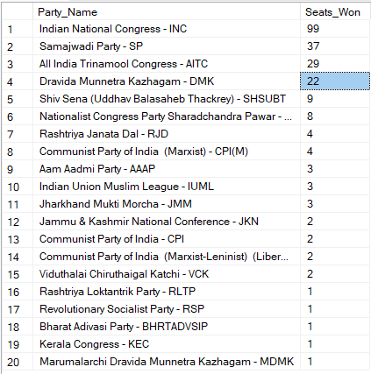

**Add new column field in table partywise_results to get the Party Allianz as NDA, I.N.D.I.A and OTHER**

ALTER TABLE partywise_results

ADD party_alliance VARCHAR(50);

**I.N.D.I.A Allianz**

UPDATE partywise_results

SET party_alliance = 'I.N.D.I.A'

WHERE party IN (

'Indian National Congress - INC',

'Aam Aadmi Party - AAAP',

'All India Trinamool Congress - AITC',

'Bharat Adivasi Party - BHRTADVSIP',

'Communist Party of India (Marxist) - CPI(M)',

'Communist Party of India (Marxist-Leninist) (Liberation) - CPI(ML)(L)',

'Communist Party of India - CPI',

'Dravida Munnetra Kazhagam - DMK',

'Indian Union Muslim League - IUML',

'Jammu & Kashmir National Conference - JKN',

'Jharkhand Mukti Morcha - JMM',

'Kerala Congress - KEC',

'Marumalarchi Dravida Munnetra Kazhagam - MDMK',

'Nationalist Congress Party Sharadchandra Pawar - NCPSP',

'Rashtriya Janata Dal - RJD',

'Rashtriya Loktantrik Party - RLTP',

'Revolutionary Socialist Party - RSP',

'Samajwadi Party - SP',

'Shiv Sena (Uddhav Balasaheb Thackrey) - SHSUBT',

'Viduthalai Chiruthaigal Katchi - VCK'

);

**NDA Allianz**

UPDATE partywise_results

SET party_alliance = 'NDA'

WHERE party IN (

'Bharatiya Janata Party - BJP',

'Telugu Desam - TDP',

'Janata Dal (United) - JD(U)',

'Shiv Sena - SHS',

'AJSU Party - AJSUP',

'Apna Dal (Soneylal) - ADAL',

'Asom Gana Parishad - AGP',

'Hindustani Awam Morcha (Secular) - HAMS',

'Janasena Party - JnP',

'Janata Dal (Secular) - JD(S)',

'Lok Janshakti Party(Ram Vilas) - LJPRV',

'Nationalist Congress Party - NCP',

'Rashtriya Lok Dal - RLD',

'Sikkim Krantikari Morcha - SKM'

);

**OTHER**

UPDATE partywise_results

SET party_alliance = 'OTHER'

WHERE party_alliance IS NULL;

**Which party alliance (NDA, I.N.D.I.A, or OTHER) won the most seats across all states?**

SELECT

p.party_alliance,

COUNT(cr.Constituency_ID) AS Seats_Won

FROM

constituencywise_results cr

JOIN

partywise_results p ON cr.Party_ID = p.Party_ID

WHERE

p.party_alliance IN ('NDA', 'I.N.D.I.A', 'OTHER')

GROUP BY

p.party_alliance

ORDER BY

Seats_Won DESC;

